CAFÉ & TIKI MENU

APPETIZERS

**WINGS**

Choose hot, bbq, salt & pepper or teriyaki,

served with veggies and dip | $14

**CHEF’S FLATBREAD**

Changes daily, ask your server about today’s feature | $15

**CHILI CHICKEN**

Lightly breaded chicken, cucumber, scallions, wonton crisps, sweet chili sauce | $14

**CRISPY CALAMARI**

Green onion and lemon zest, served with a cucumber dill dip | $15

**PERSONAL NACHOS**

Classic NSWC Nachos but you don’t have to share! Topped with tomatoes, jalapenos, black beans, green onions and melted cheese blend. Served with salsa and sour cream | $13

BURGERS & SANDWICHES

**Served with choice of fries, yam fries or salad**

**JIM GRAHAM BURGER**

Lettuce, tomato, bacon, cheddar, NSWC burger sauce, on a toasted brioche bun

Beef | $18 Chicken | $19

**BLACKENED CHICKEN SANDWICH**

Bacon, Havarti cheese, chipotle mayo, crispy onions, lettuce, tomato, on

toasted ciabatta | $17

**NSWC ‘CLUB’ SANDWICH**

Roasted turkey, bacon, lettuce, tomato, sliced cheddar and mayonnaise, choice of

toasted bread| $16

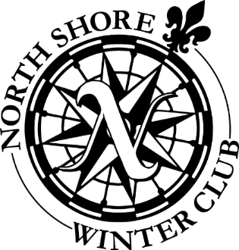

SALADS & BOWLS

**GRILLED SALMON SALAD**

Strawberries, spinach, red onions, sunflower seeds and feta, strawberry balsamic dressing,

grilled salmon | $20

**CHICKEN PANZANELLA SALAD**

Spinach, tomatoes, red onions, Kalamata olives, parmesan and croutons, poppy seed dressing and grilled chicken | $19

**KOREAN BBQ BEEF RICE BOWL**

Korean BBQ beef, garlic, ginger and onions, served over rice | $18

BREAKFAST

**TEX MEX BURRITO**

Egg, cheddar, black beans and avocado,

salsa | $6.50

**CHEFS OMELETTE**

Rotating ingredients, ask your server about today’s feature, served with hashbrowns | $14

KIDS MENU

**ALL ITEMS $8**

**GRILLED CHEESE SANDWICH**

**CHICKEN & CHEESE QUESADILLA**

**CHICKEN STRIPS, SERVED WITH PLUM SAUCE**

**KIDS BEEF BURGER**

All above served with fries or veggie sticks

**PEPPERONI FLATBREAD**

**CHEESE FLATBREAD**

**MARINA SPAGHETTI**